**Task 1: Create a new storage bucket, 3 new folders, add data into the newly created folders in GCP**

**Prerequisies:** Google/Gmail account with access to Google cloud console and a pre-created project.

**Step 1: Storage bucket creation**

* Login to GCP console. If you are using Crome browser with Google/Gmail credentials, then you don’t need to login.
* Make sure the previously created project is selected.
* Click on the Navigation menu on the top left corner of the page(three horizontal bars beside the text Google Cloud)

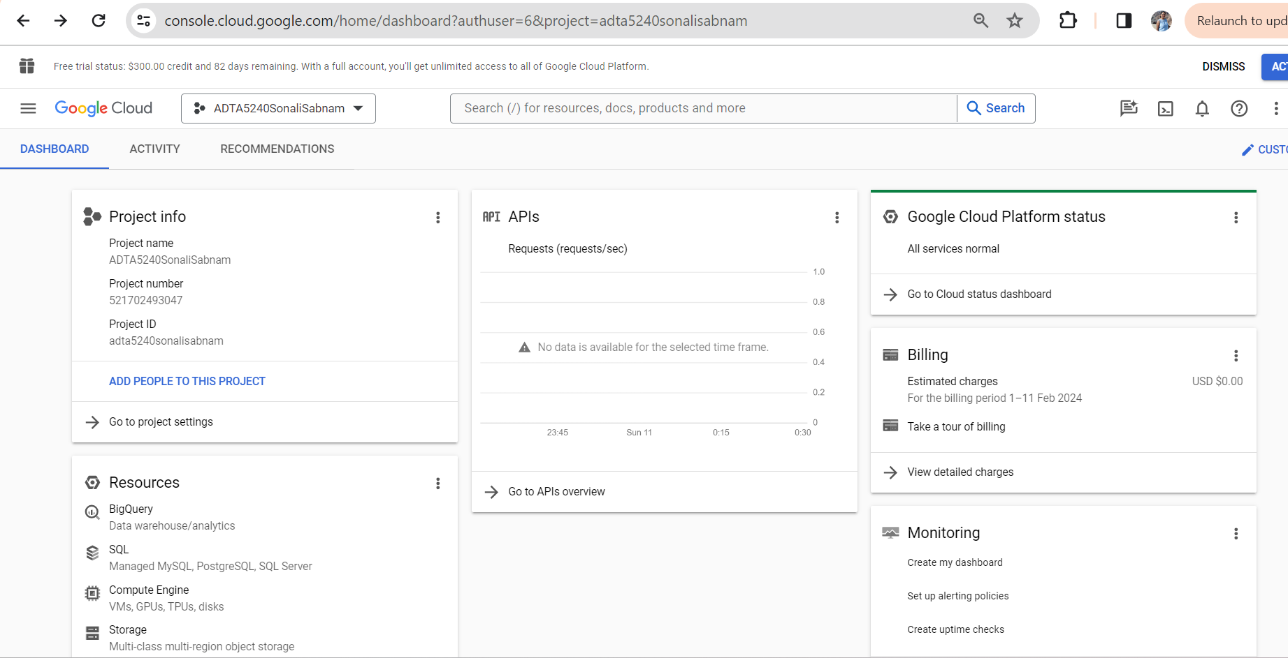

* Once the menu is displayed, hover on “Cloud Storage”🡪 “Buckets” and click.

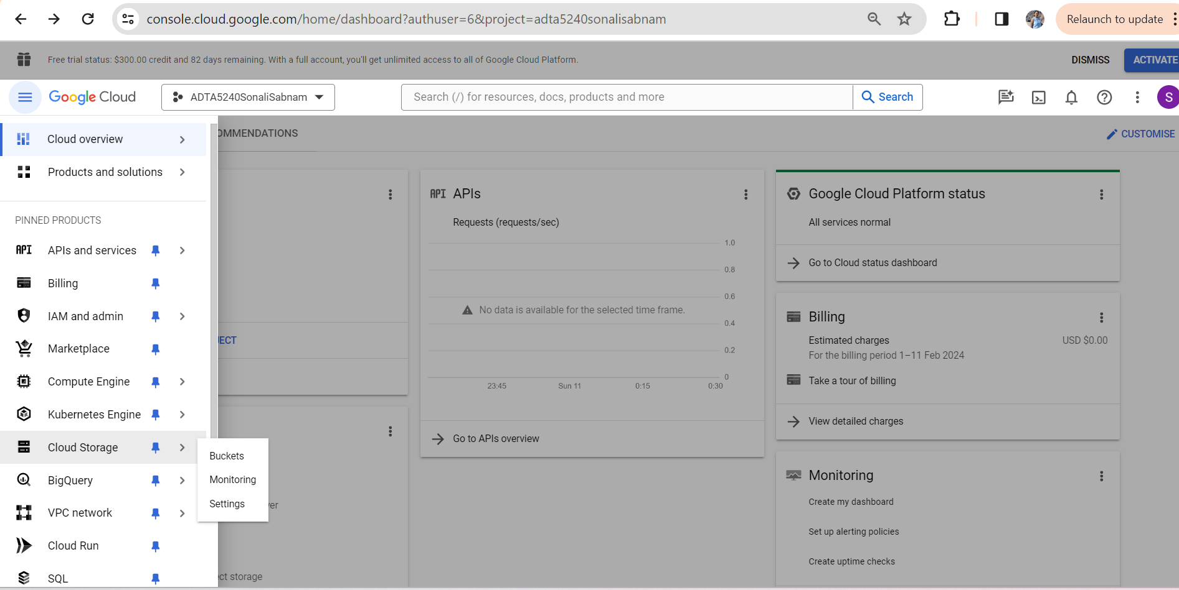

* The below screen gets loaded.

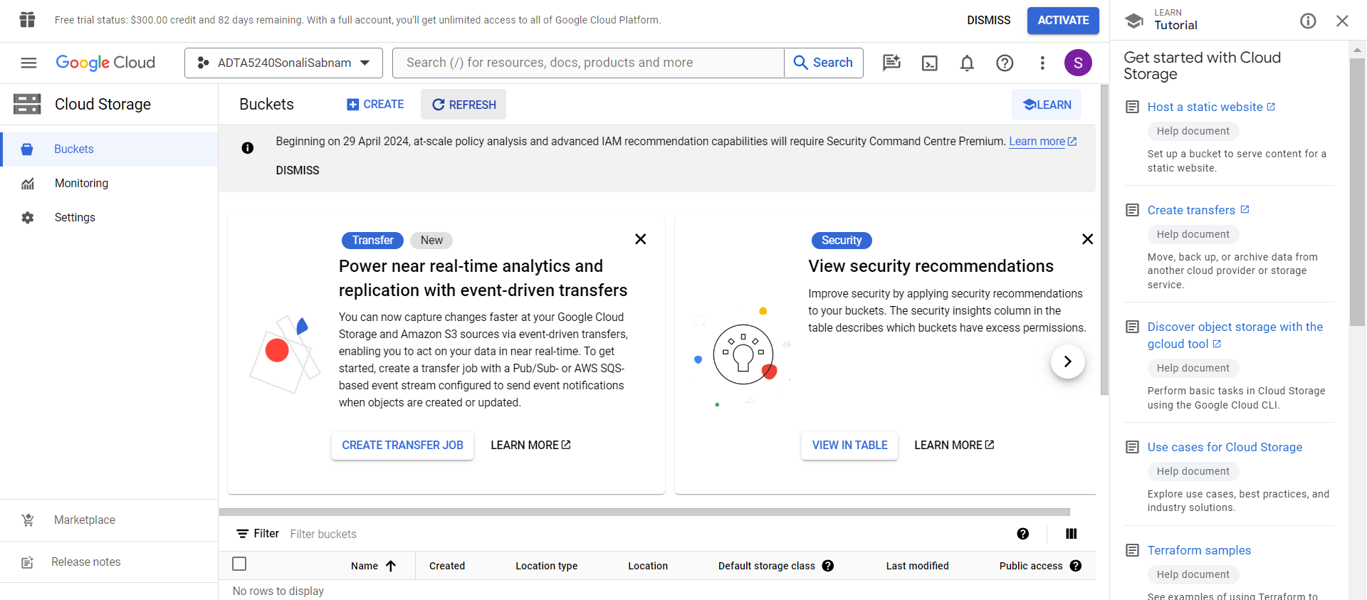

* Now, click on CREATE
* The below screen gets loaded.

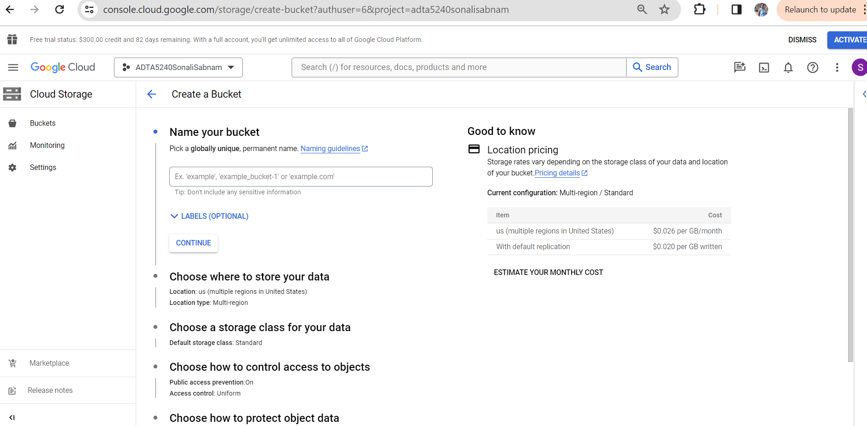

* Enter a name for your bucket in small letters.
* I have named my bucket as “adta5240sonalibucketone”

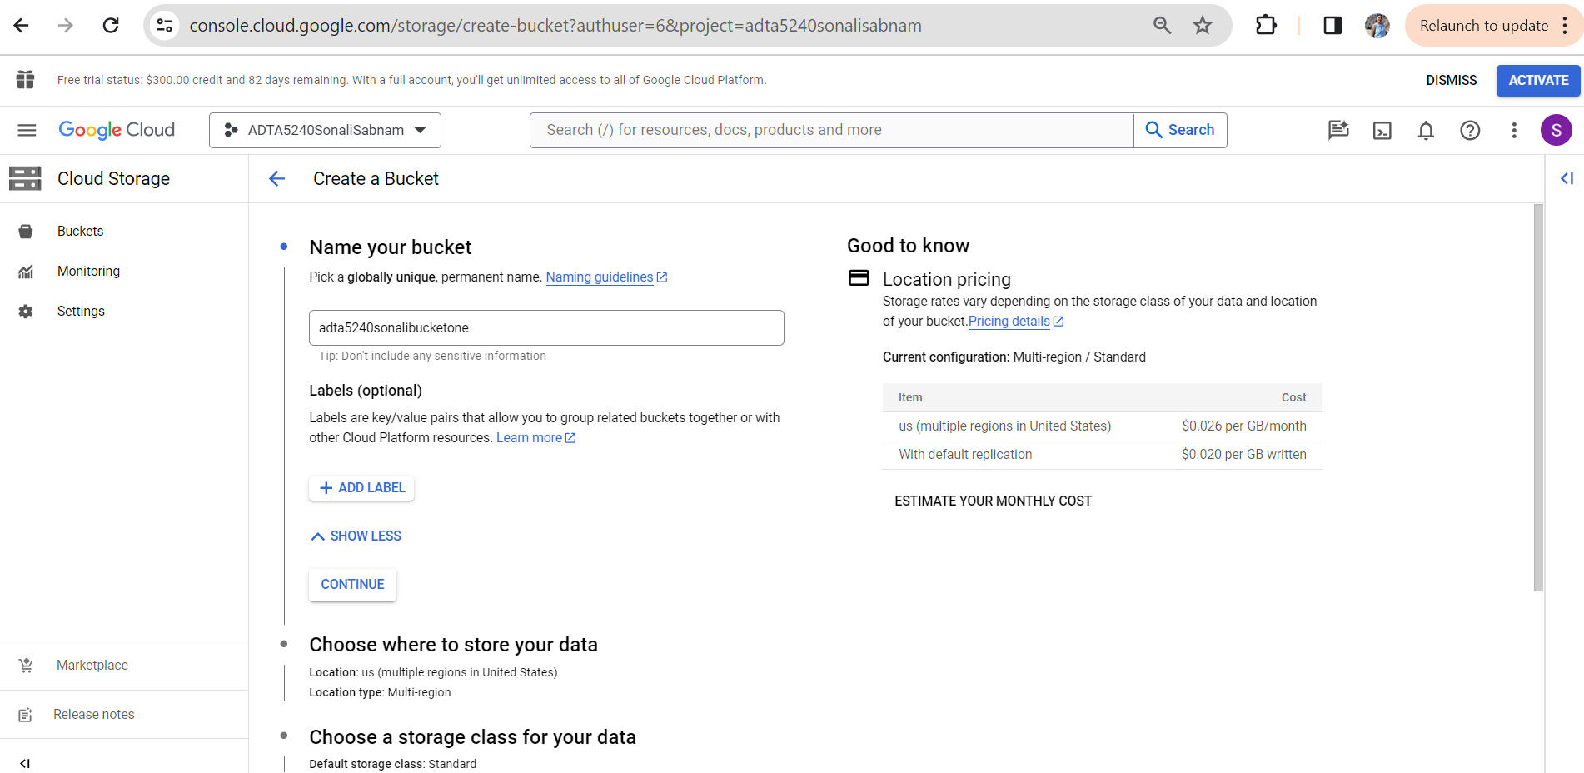

* Click on “CONTINUE”
* The below screen gets loaded.

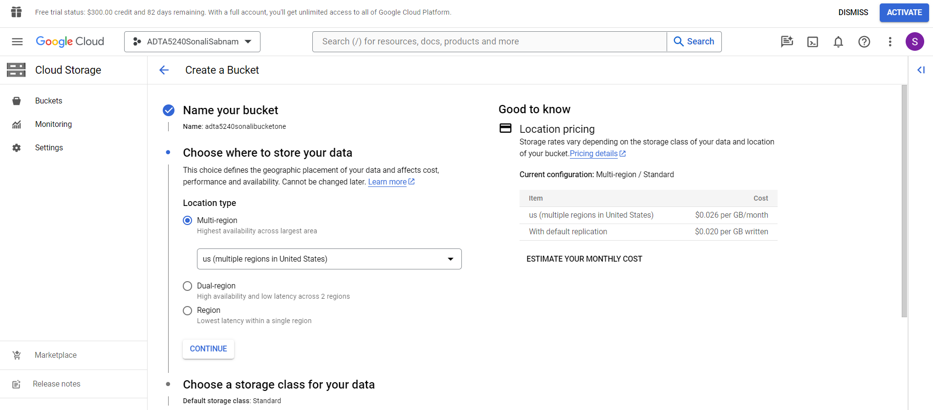

* For Location type, default “Multi-region” and us(multiple regions in United States) is selected.
* Click on “CONTINUE”.
* The below screen gets loaded.

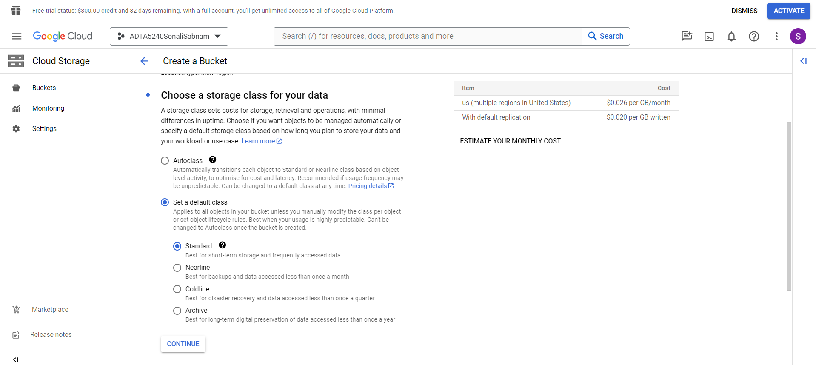

* In the “Choose a storage class for your data” section, “Set a default class” and “Standard” is selected by default. Do not make any changes as we need the same settings.
* Click on “Continue”.
* The below screen gets loaded.

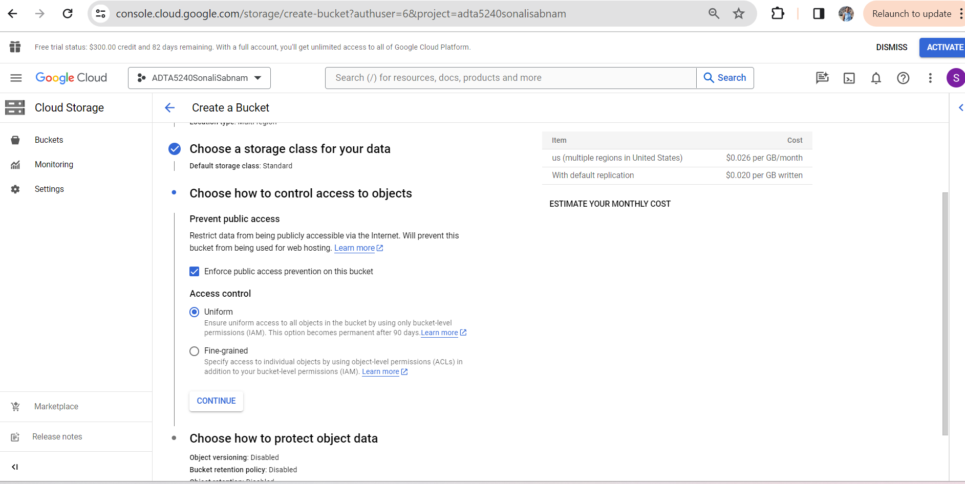

* For Access control, “Uniform” is selected by default. Do not make any changes as we need the same setting.
* Click on “CONTINUE”.
* The below screen gets loaded.

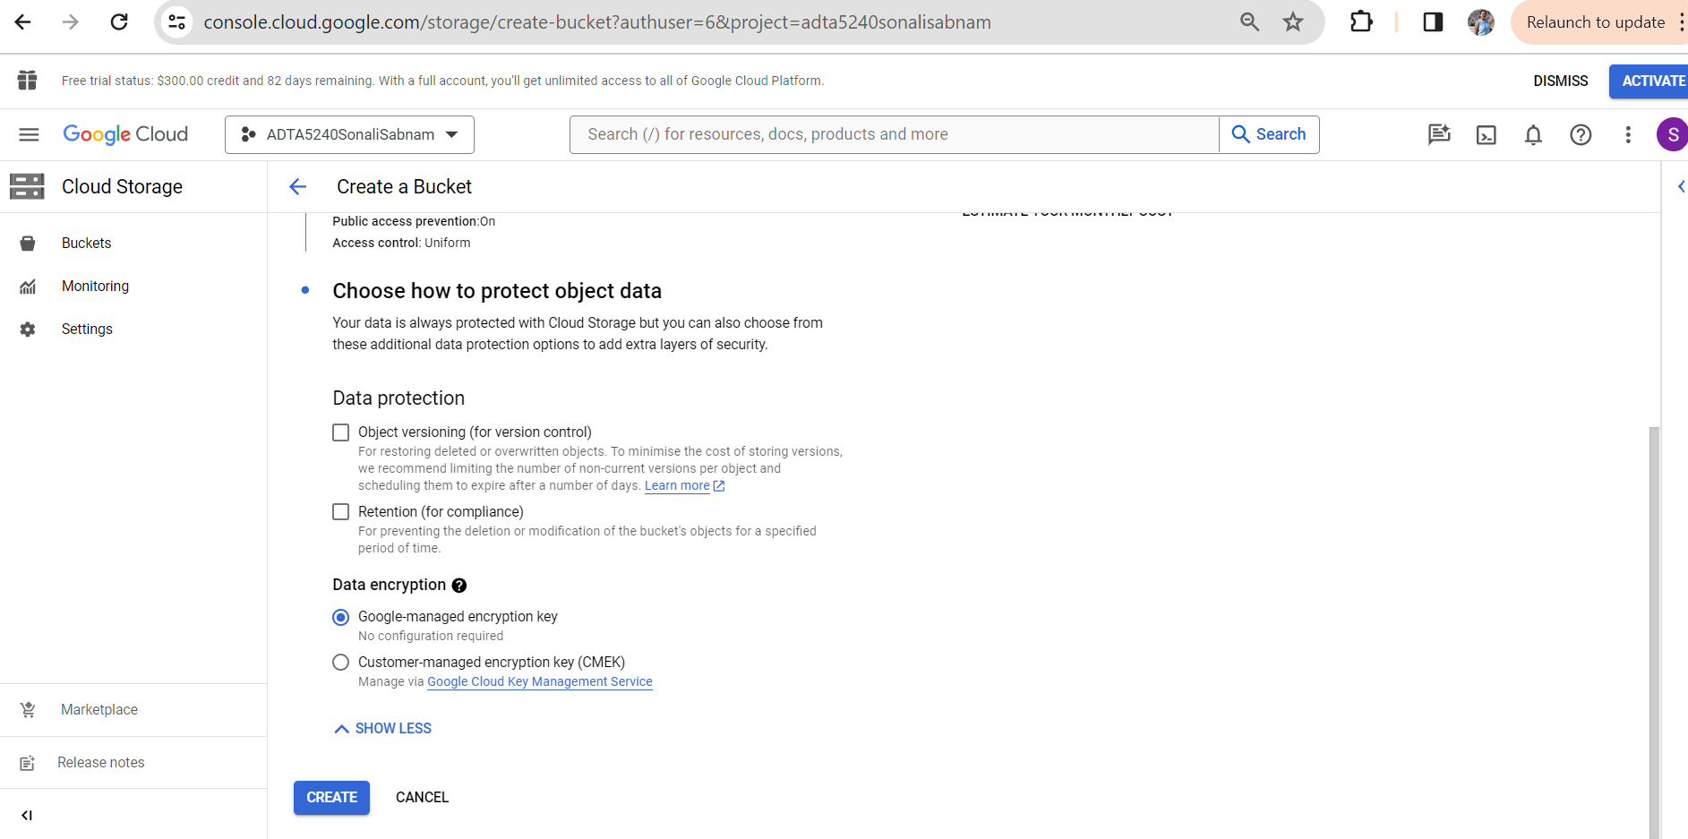

* Do not make any changes here as we don’t need any additional protection.
* Click on “CREATE”.

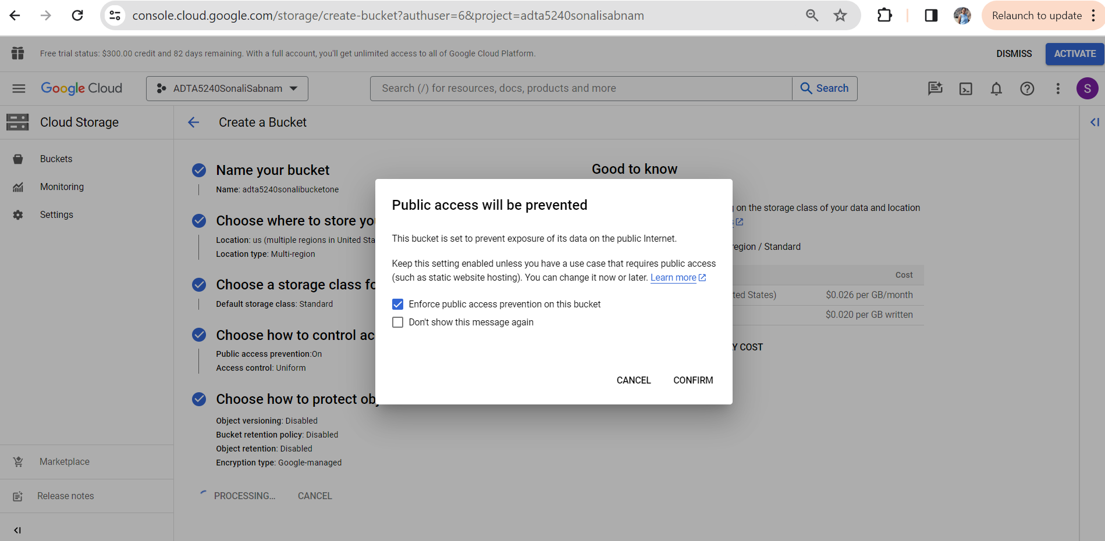

* The above screen gets loaded.
* “Enforce public access prevention on this bucket” is checked by default. Do not make any changes.
* Click on “CONFIRM”.
* The bucket is created, and the below screen gets displayed.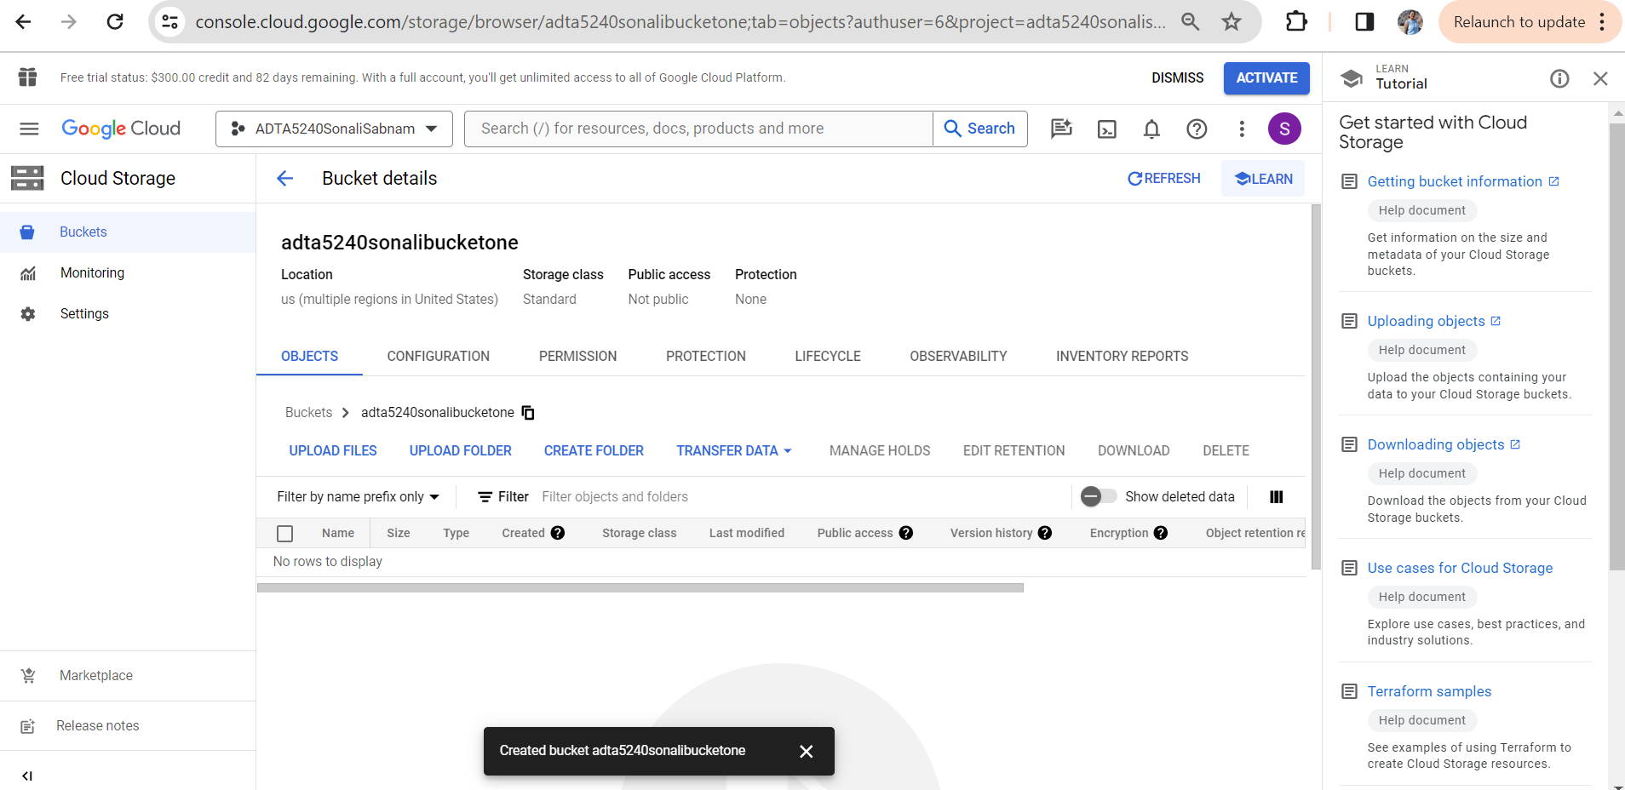

**Step 2: Create three folders “data”, “logs” and” outputs”.**

* Go to the storage bucket if not already.
* Click on “CREATE FOLDER”.

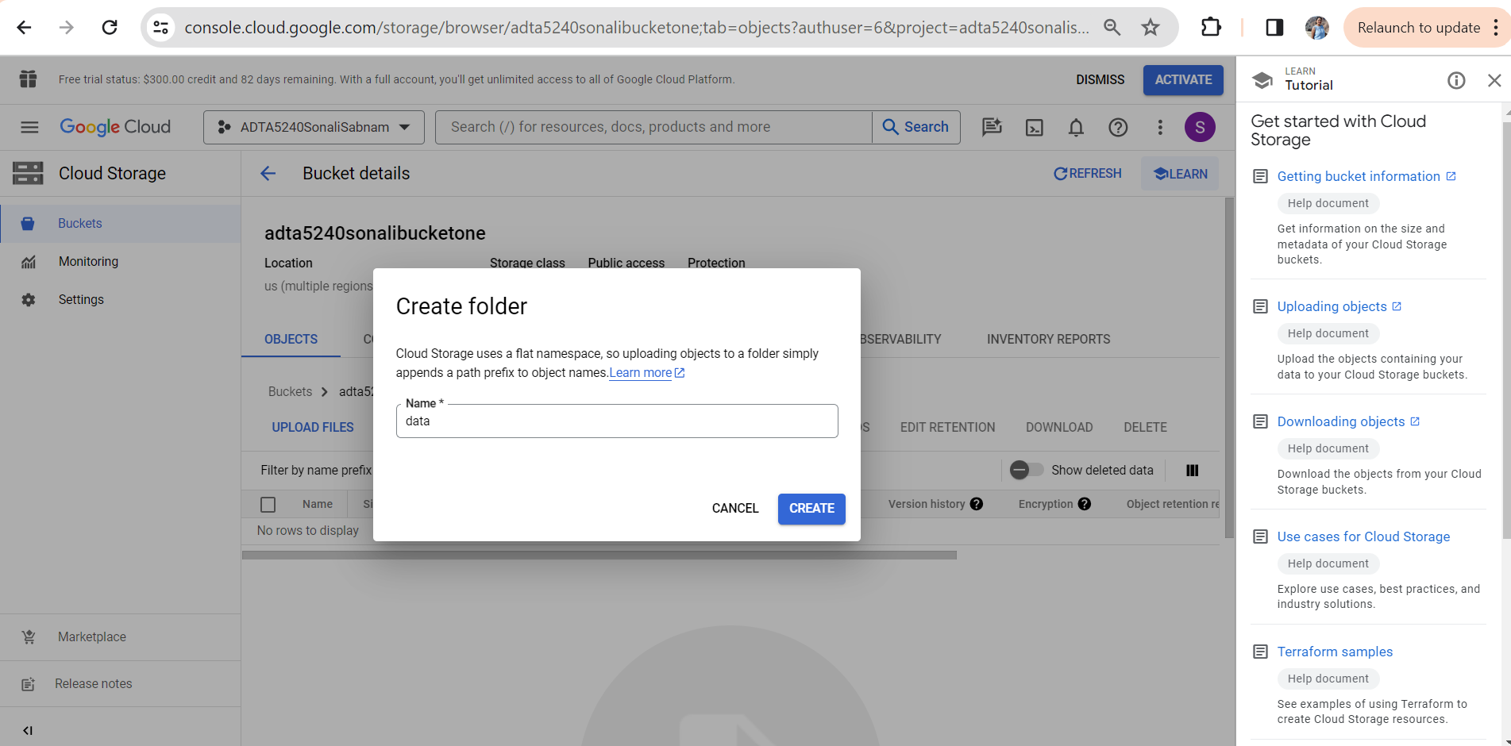

* The above screen gets displayed. I have named this folder as “data”.
* Click on “CREATE”.
* The folder gets created as displayed in the below screenshot.

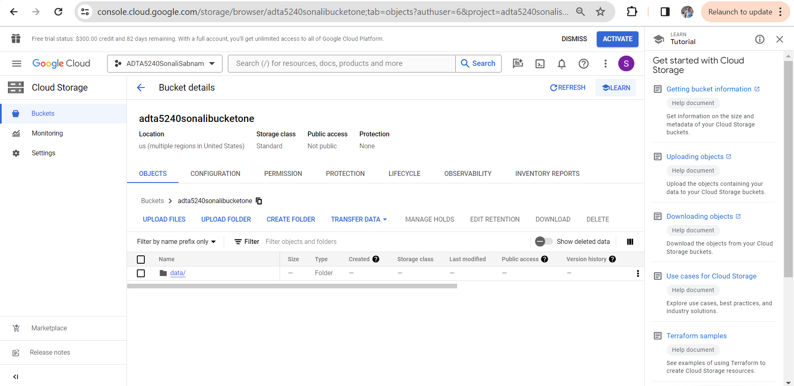

* Create “logs” and “outputs” folder similarly.

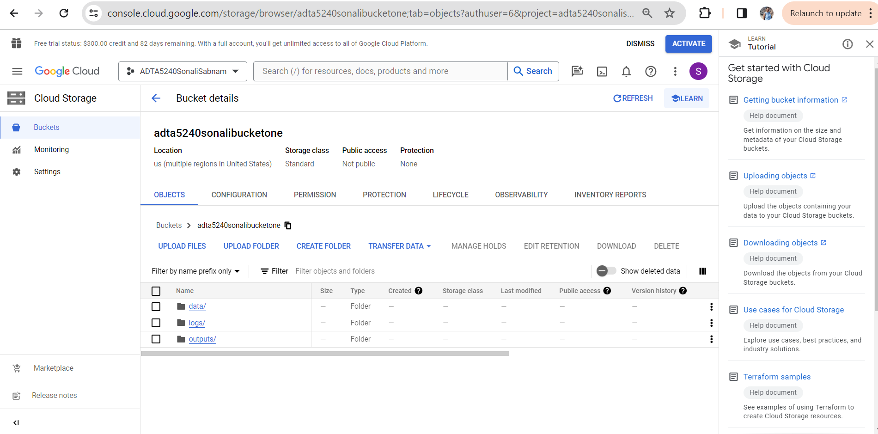

**Step 3: load data into the GCP storage bucket**

* Go to the storage bucket if not already.
* Click on the data folder.
* The blow screen gets displayed.

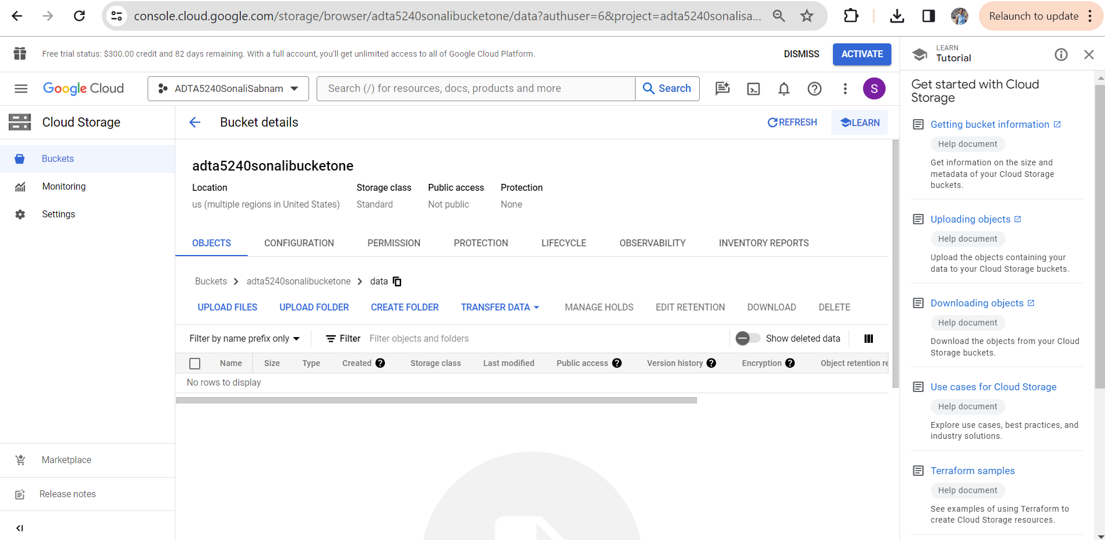

* Now, click on “UPLOAD Files”.
* The below screen gets displayed.

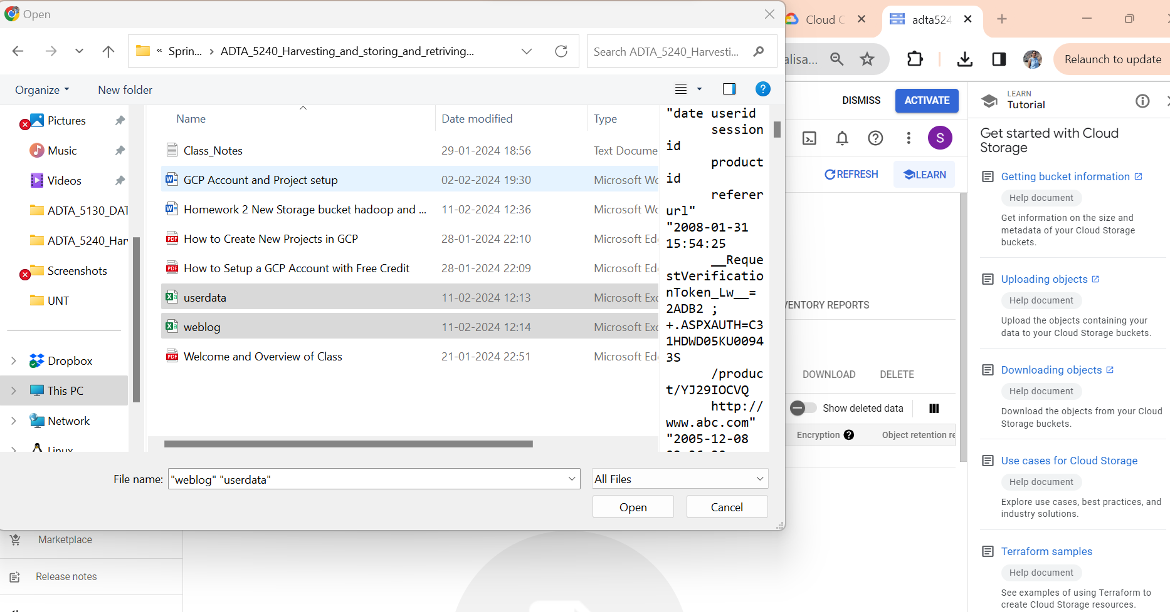

* I have selected “weblog” and “userdata” files from my machine.
* Click on “Open”.
* The below screen get loaded with the files showing in the “data” folder.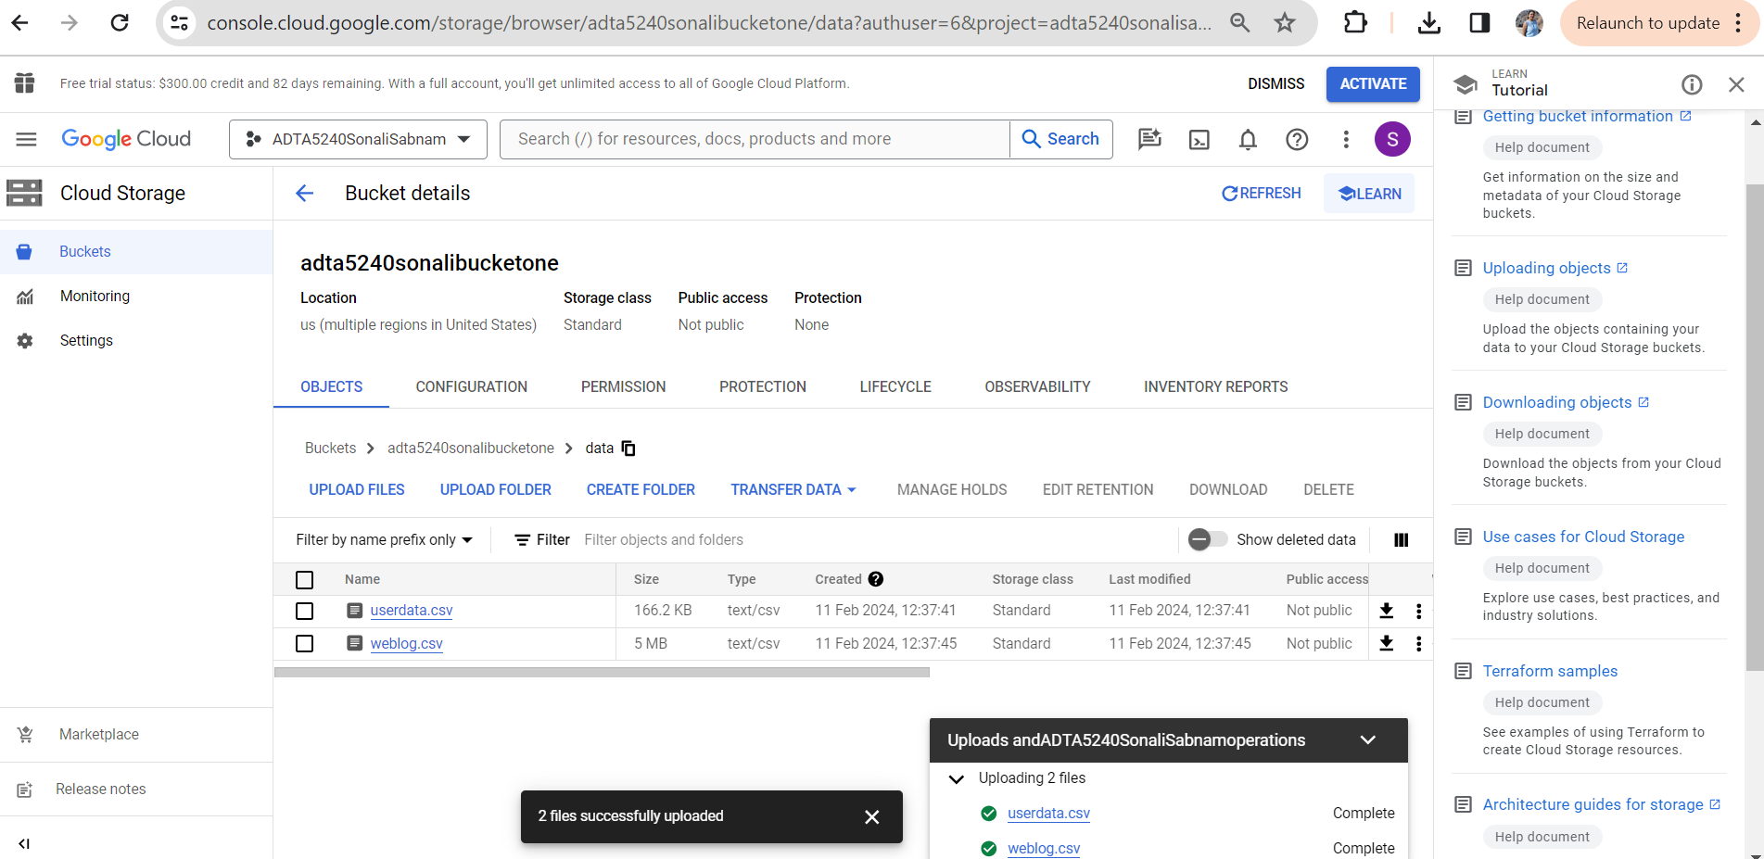

**Task 1 Conclusion:**

* With this the storage bucket is created successfully, the folders are created and data is loaded successfully.

**Task 2: Create Hadoop and Spark Cluster in GCP**

**Prerequisies:**

* Google/Gmail account with access to Google cloud console
* Project with Storage bucket

**Step 1: GCP Compute Engine API**

* Click on the navigation menu. Hover on “API and Services” and click on “Enabled API and Services.

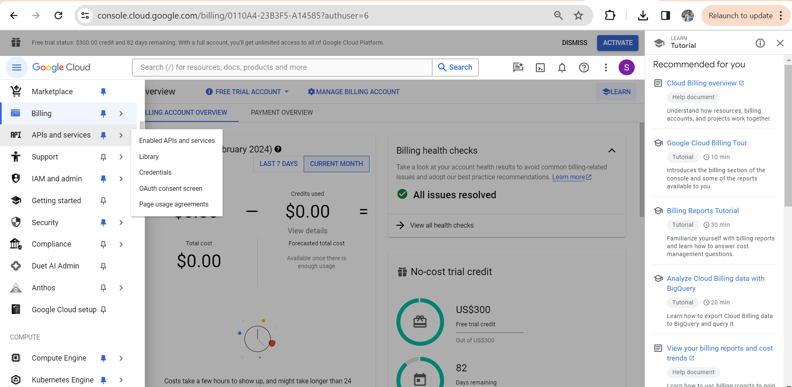

* The below screen gets loaded.

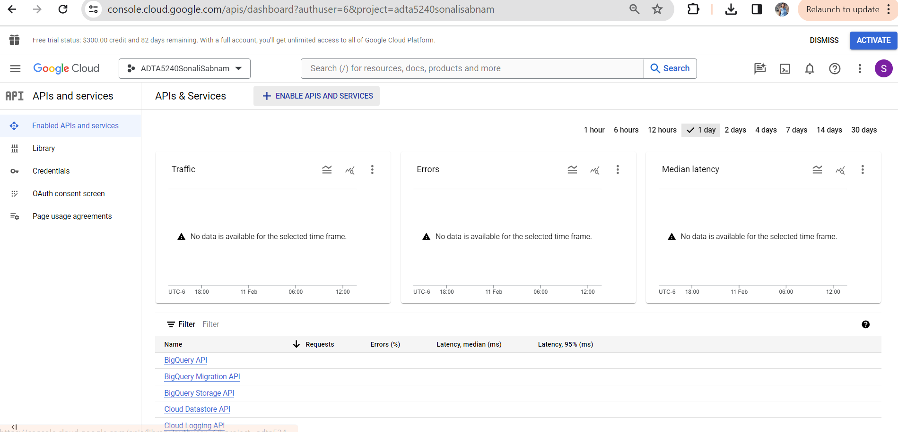

* In the search bar type “Compute Engine API”
* The below screen gets loaded.

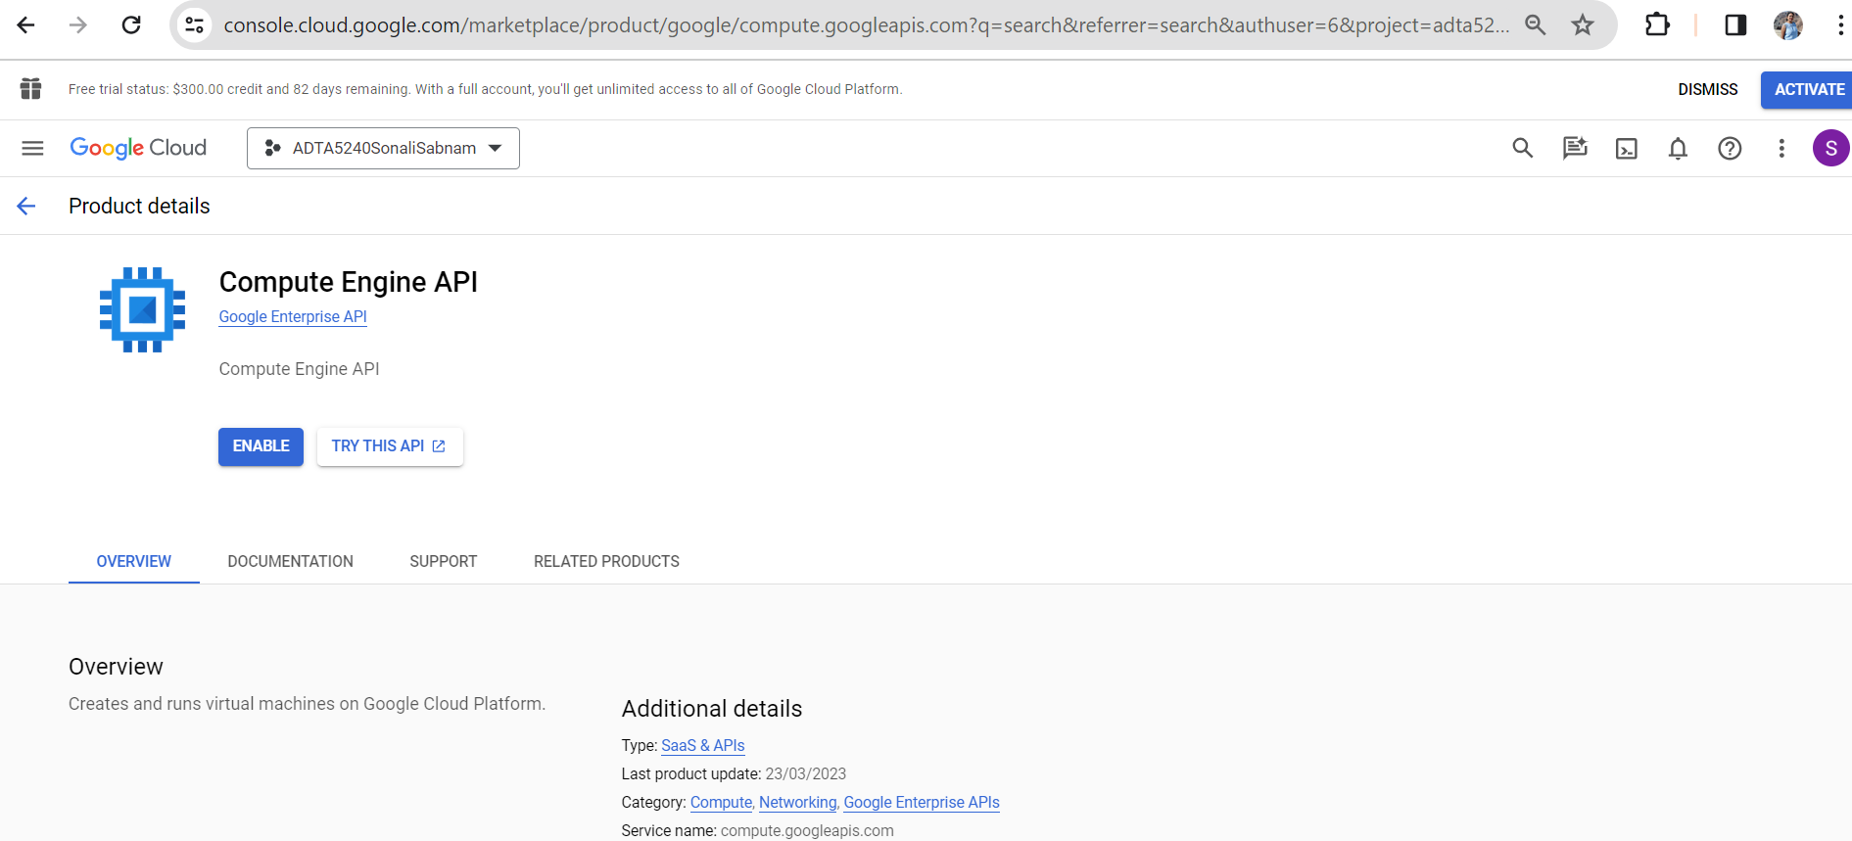

* Click on “Enable”.
* Now, the Compute Engine API is enabled, and the below screen is displayed.

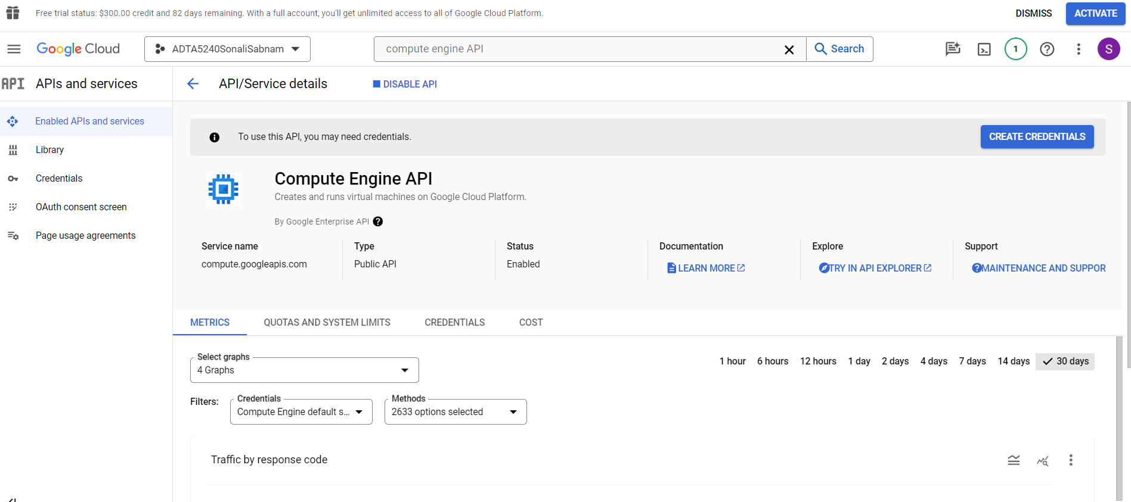

**Step 2: Cloud DataProc API**

* Go to the search bar and type “dataproc API”
* The below screen gets displayed.

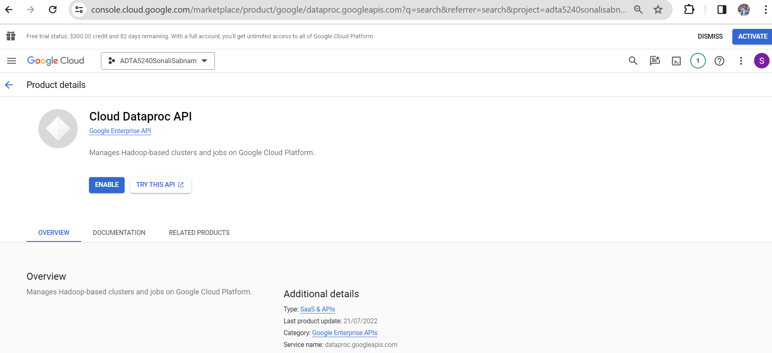

* Click on “Enable”. Cloud Dataproc API is now enabled and the below screen is displayed.

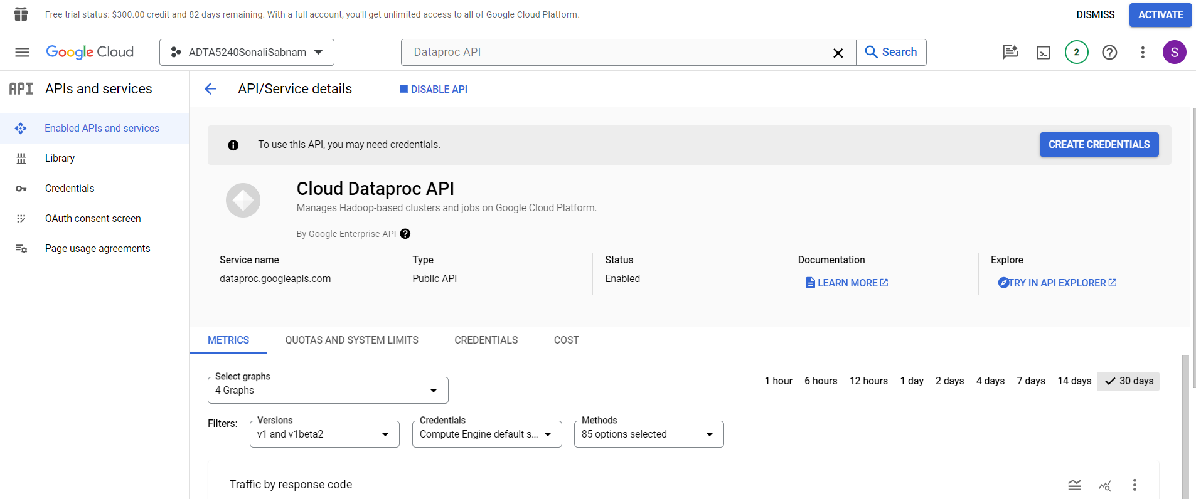

**Step 3: GCP Dataproc cluster**

* In the search bar type “clusters”. Click on the “Clusters Dataproc”.
* The below screen is displayed.

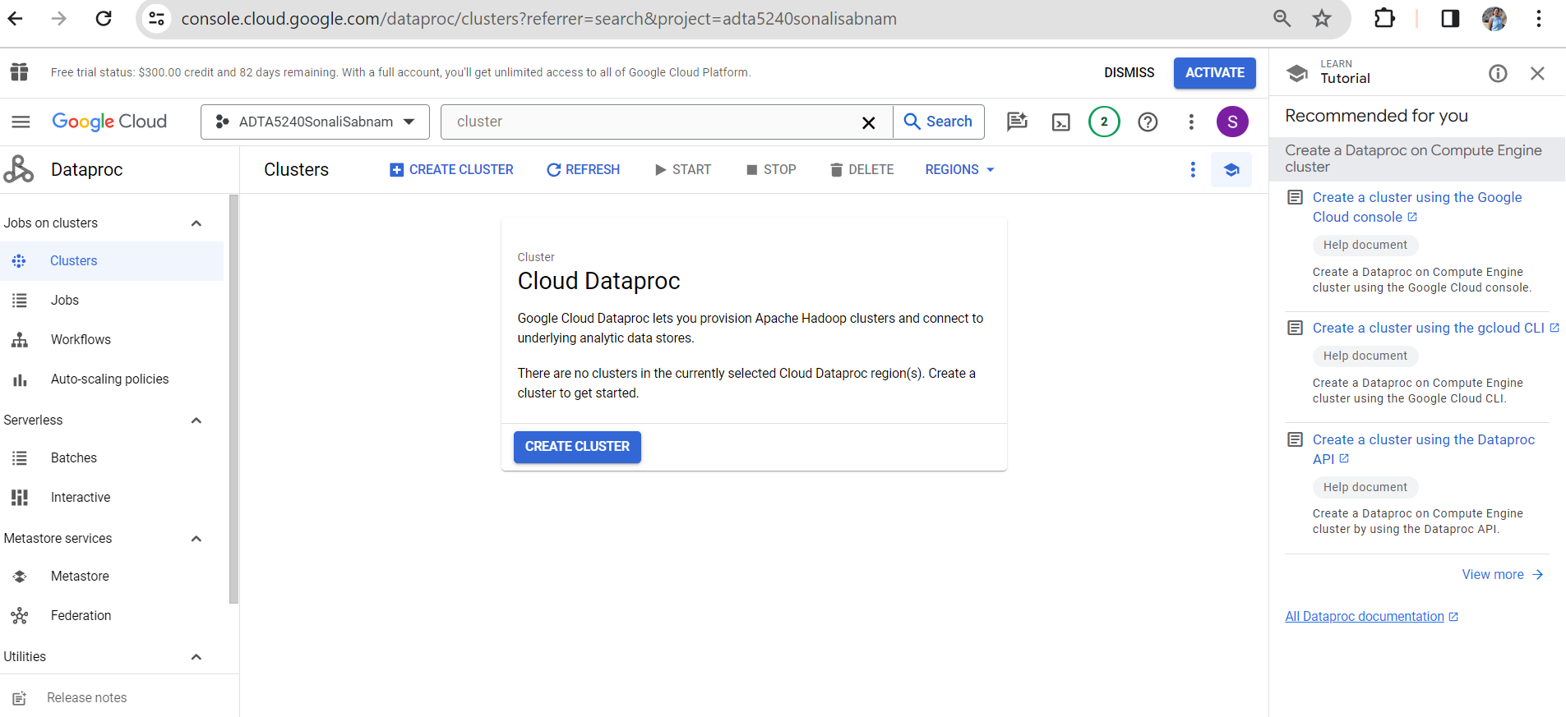

* Click on “CREATE CLUSTER”. The below pop-up is displayed.

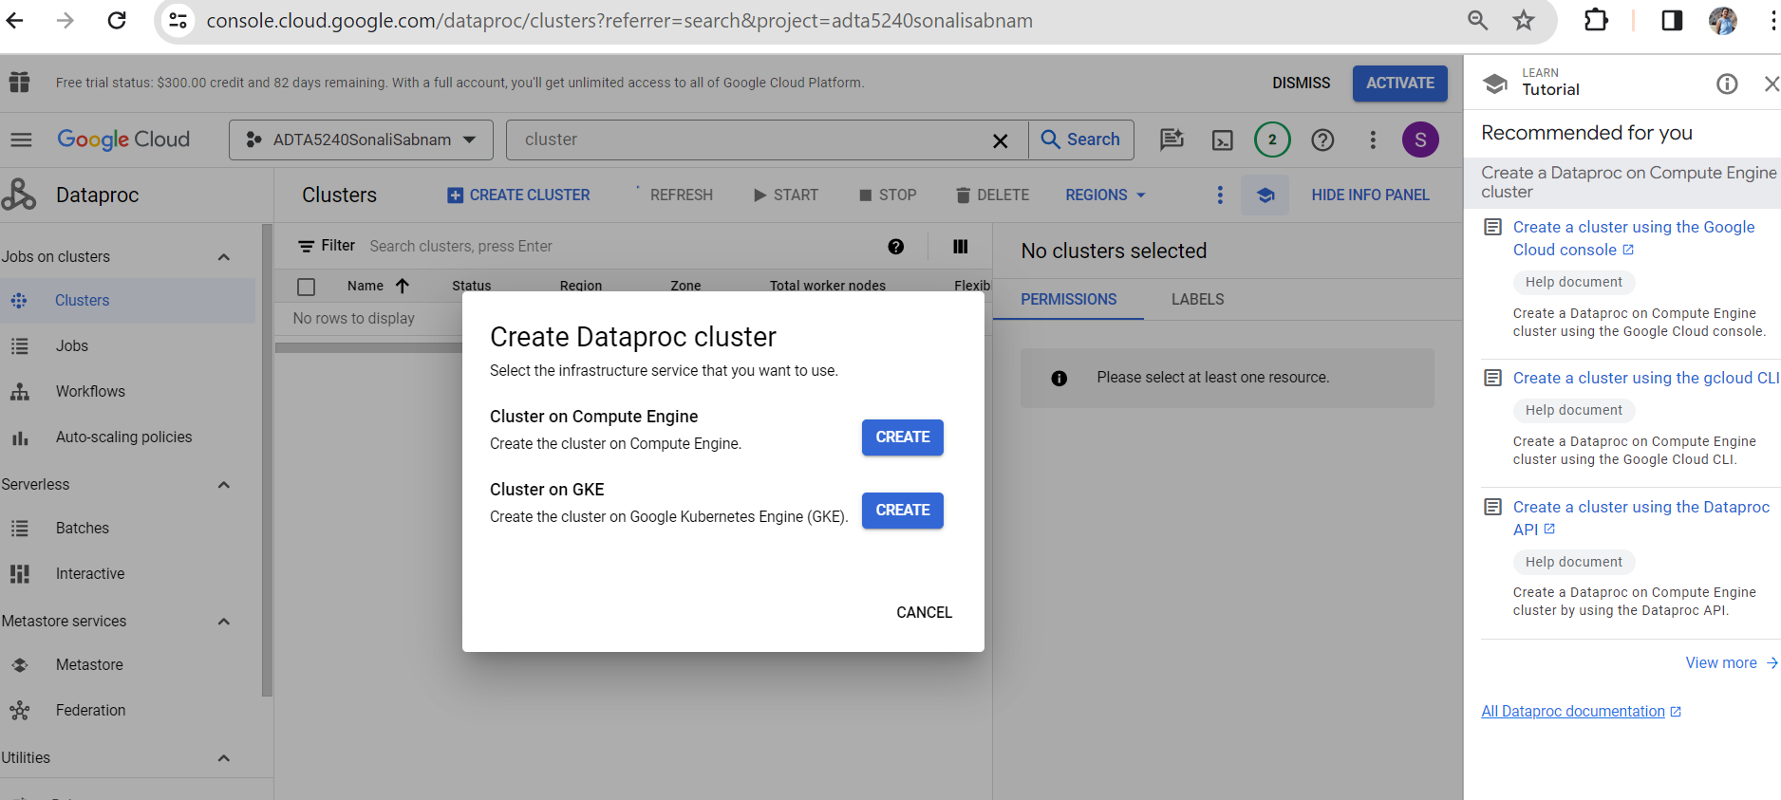

* Click on “CREATE” for “Cluster on Compute Engine”.
* The below screen is displayed.
* I have given Name as “adta5240sonalicluster”.
* “Location” and “zone” are selected by default.
* “Cluster type” is also selected by default. Do not make any changes.

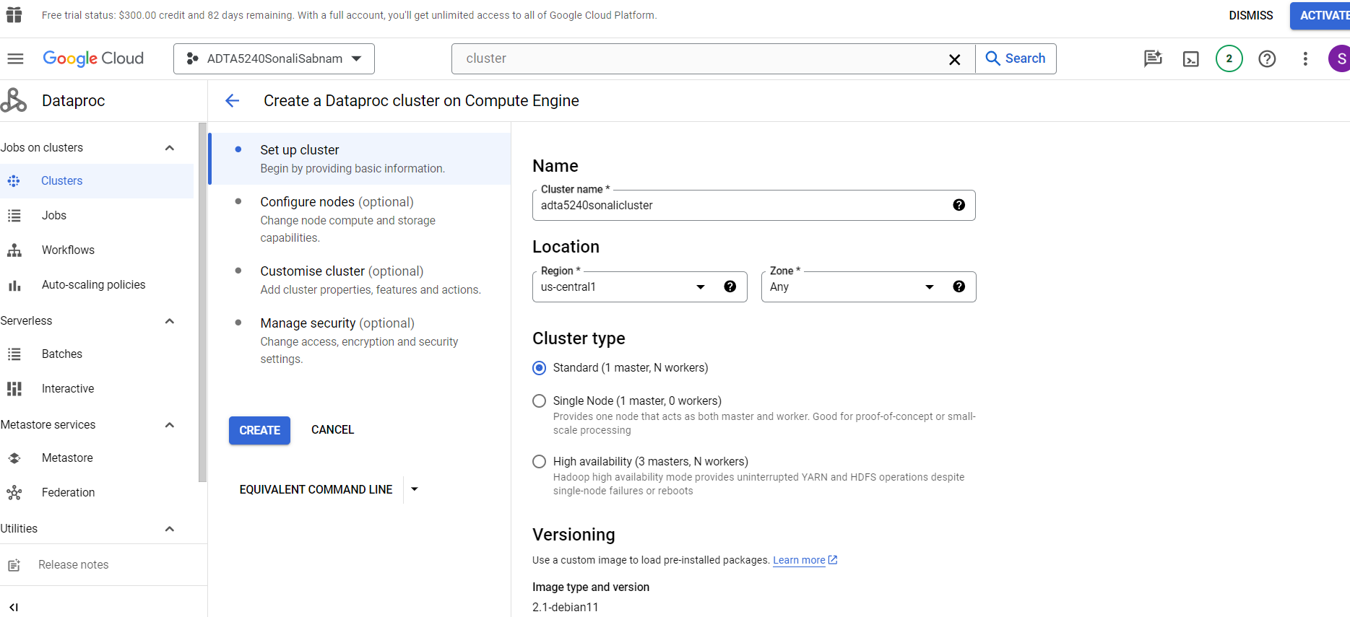

* Click on “Configure Nodes”.
* Enter “Series” as “E2”.
* Select “Machine Type” as “e2-standard-8(8 vCPU, 4 core, 32 GB memory) as displayed below.

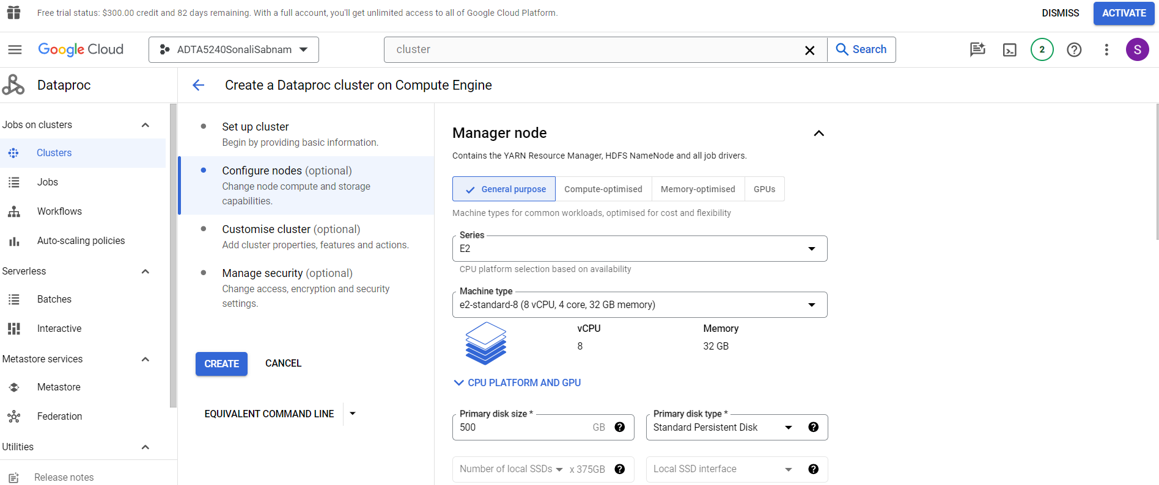

* Scroll down to “Worker nodes” section.
* Select “Series” as “E2”.
* “Machine type” as “e2-standard-4(4 vCPU, 2 core, 16 GB memory)
* “Number of worker nodes” as 2.
* “Primary disk size” as 500, “primary disk type" as “Standard persistent disk” which is default. Do not make any changes.

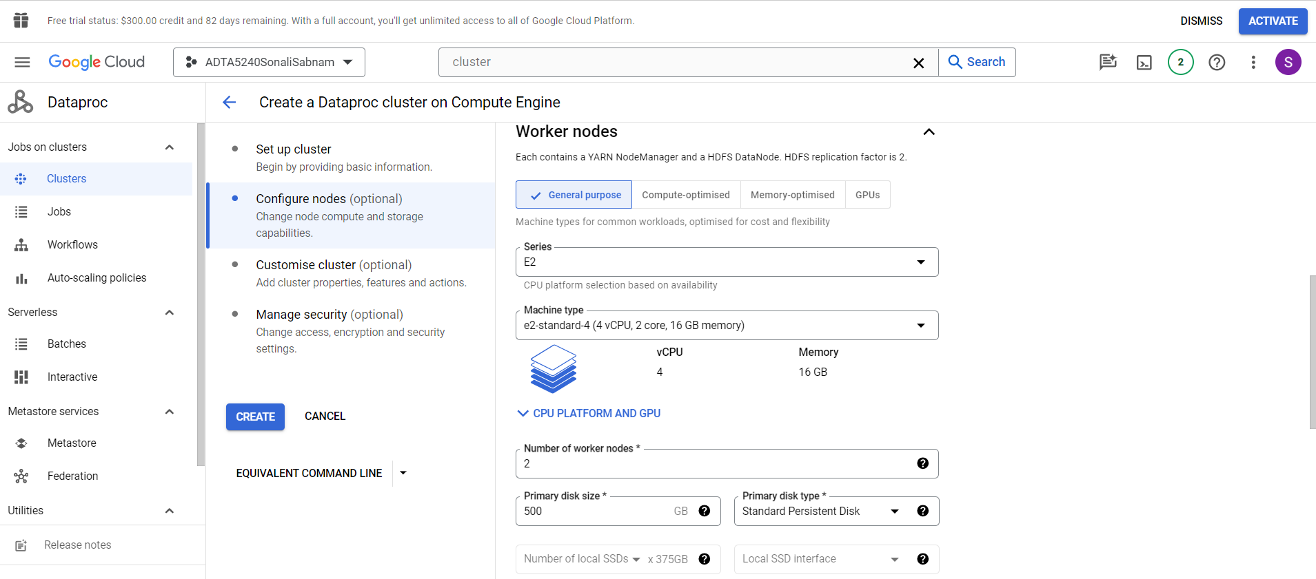

* Click on Customise cluster.
* Do not change any default settings.

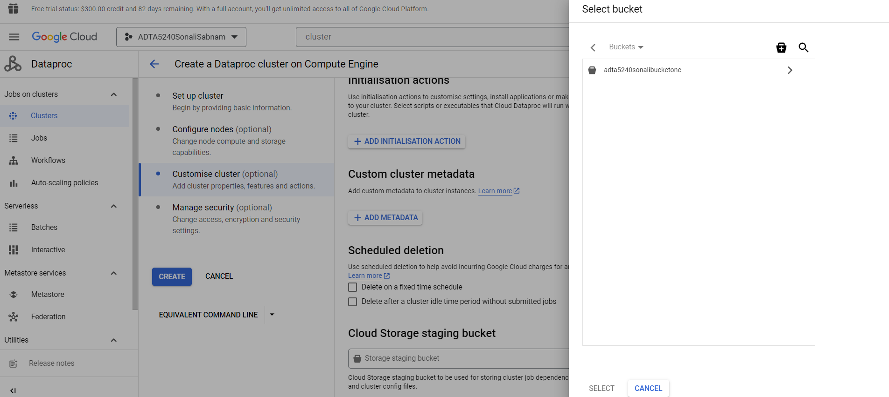

* Scroll down to “Cloud Storage Staging Bucket” and click on “Browse”.
* Select the bucket that was created earlier. For me it is “adta5240sonalibucketone”.
* The below screenshot shows the same.

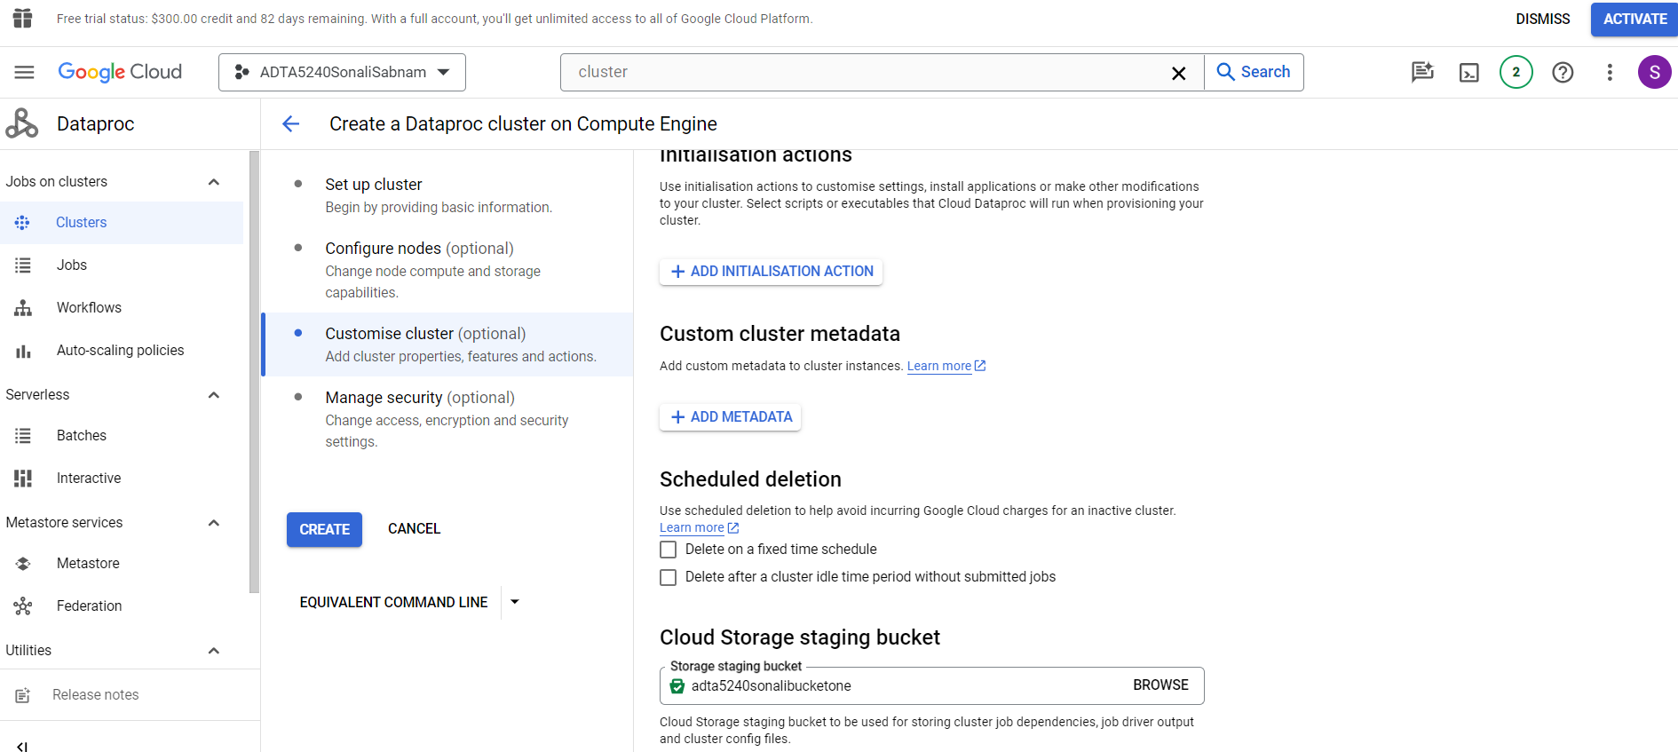

* Now click on “CREATE”.
* Now the cluster is created, and it is in “Running” mode.

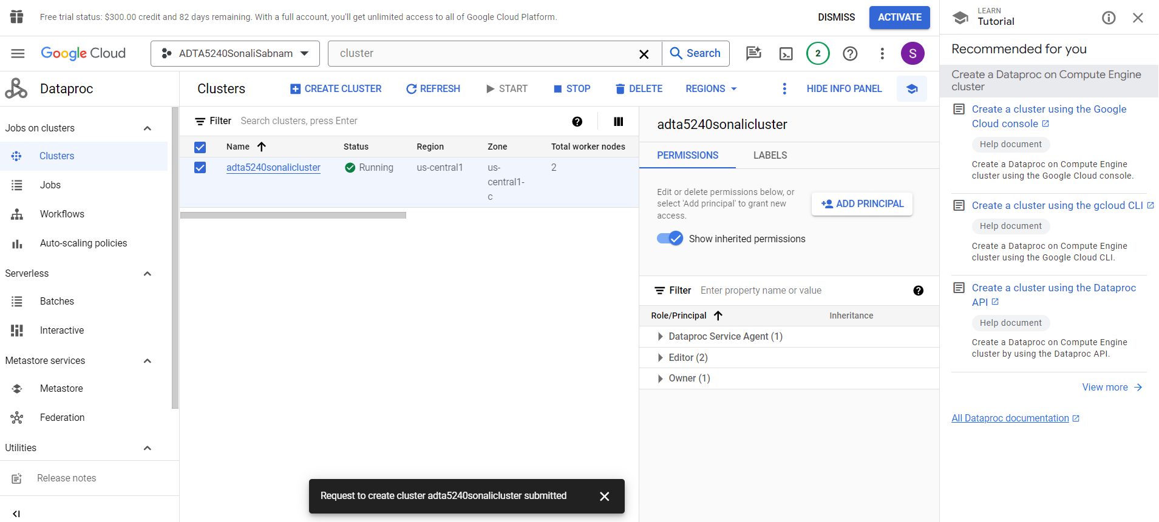

* In the below screenshot, we can see that the cluster is attached to desired storage bucket.

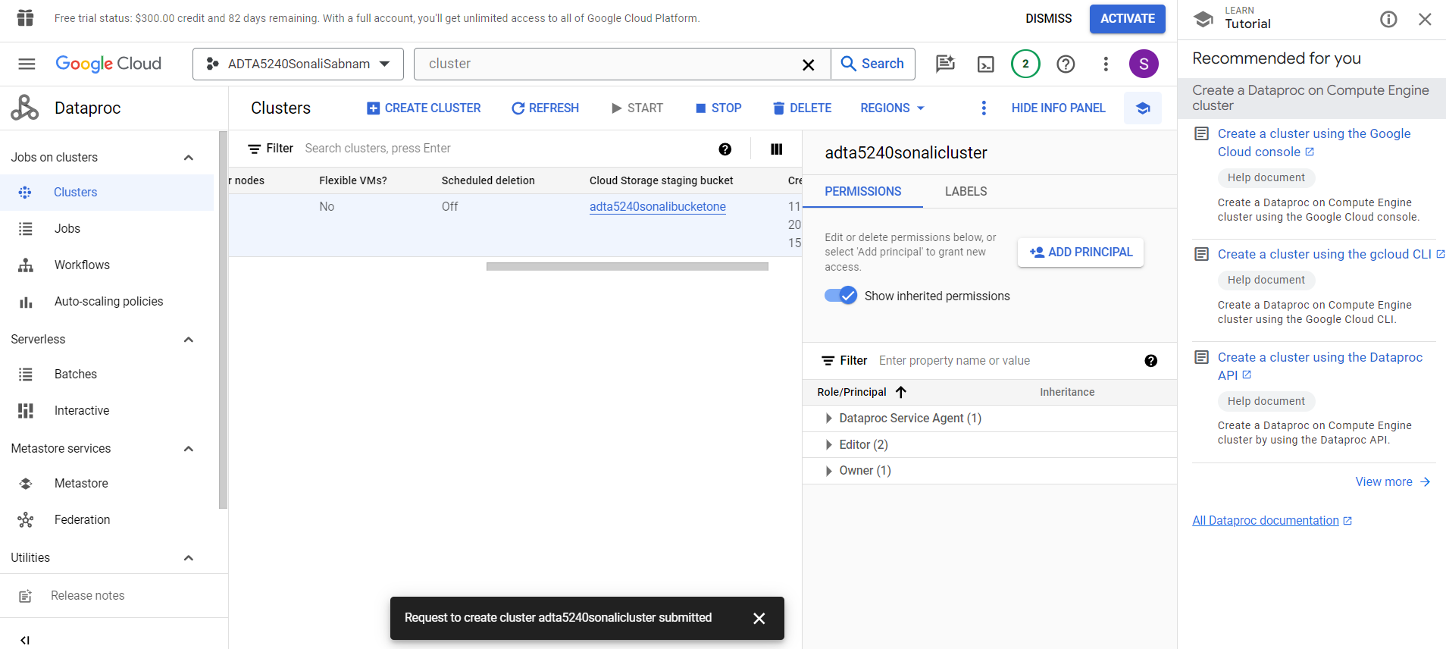

**Step 4: STOP the Cluster**

* Select the cluster and click on “STOP”.
* The below pop-up is displayed.
* Click on “Confirm”.

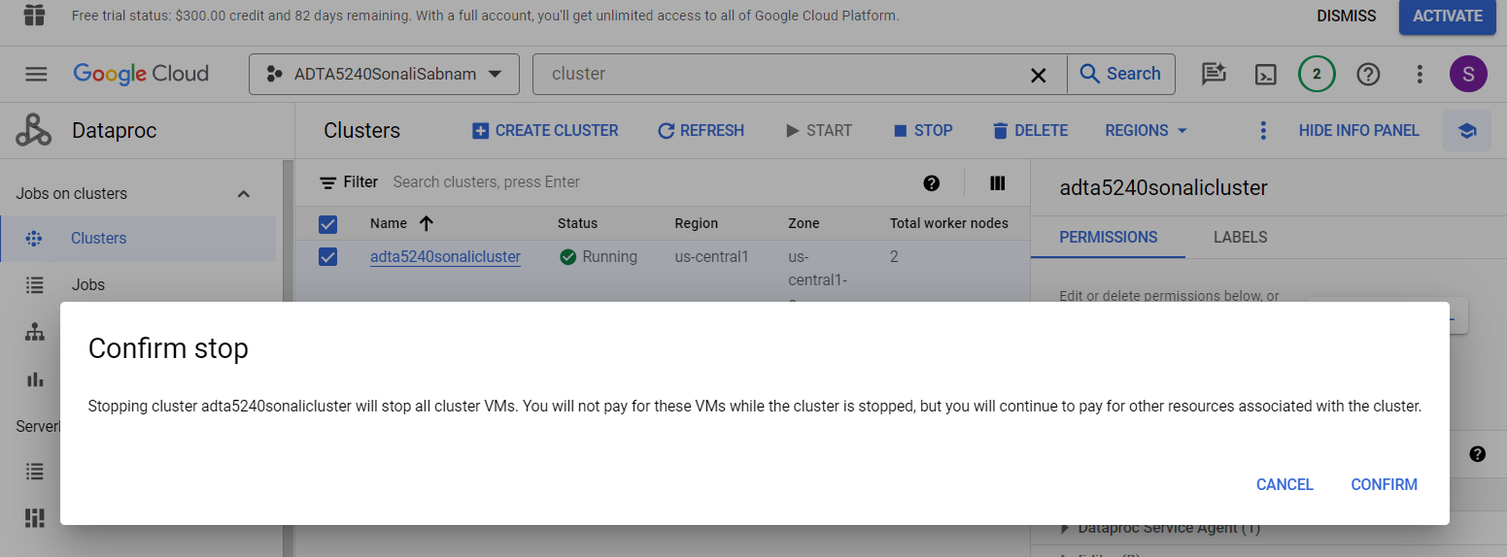

* Now the cluster is stopped, and the green tick mark is gone.
* Now the status is showing as “Stopped”.

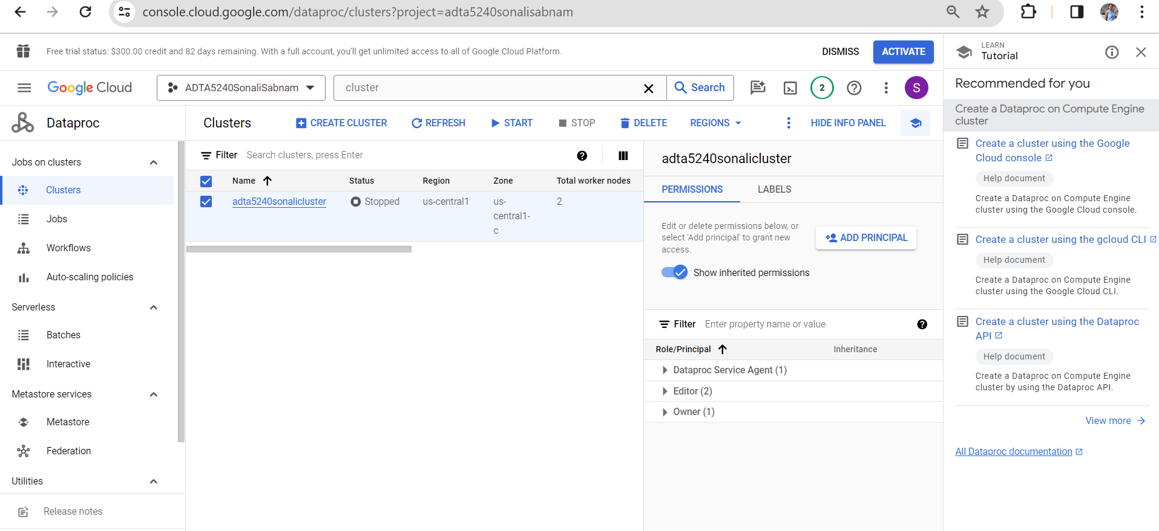

**Step 4: Re-verify if the Cluster is stopped.**

* From the main Navigation meu, go to “Compute Engine”🡪”VM Instances”.
* Here there is a manager node and two worker nodes.
* We can see in the below screenshot that the status is “stopped” and there is no green tick mark with “Running” status.

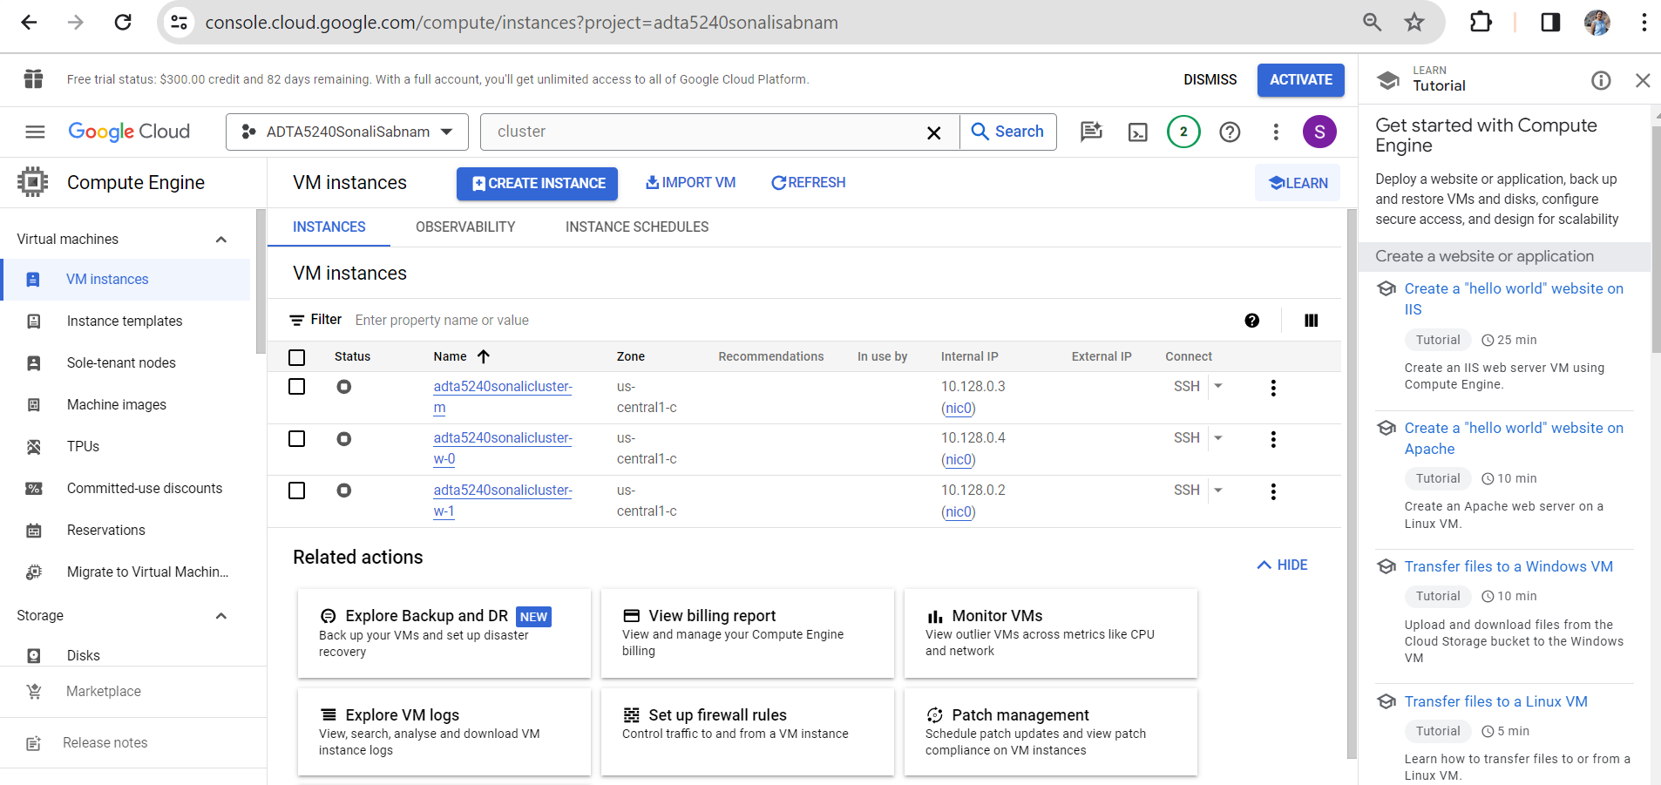

**Task 3: START and STOP a Cluster in GCP**

**Step 1: START the Cluster**

* Go to the Navigation Menu and hover on “Compute Engine”🡪”VM Instances”.
* The below screen is displayed where we can see the manager and worker nodes.

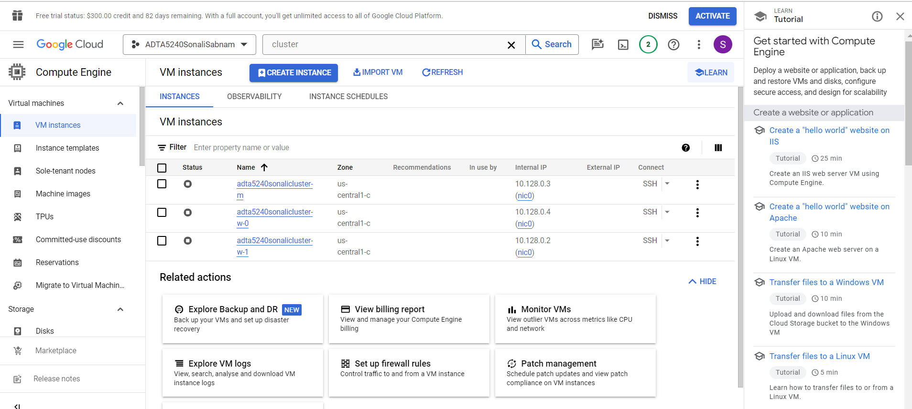

* Click on the checkbox besides “Status”. It selects all the three check boxes and click on “START/RESUME”.
* The below pop-up is displayed. click on “START” to start the cluster.

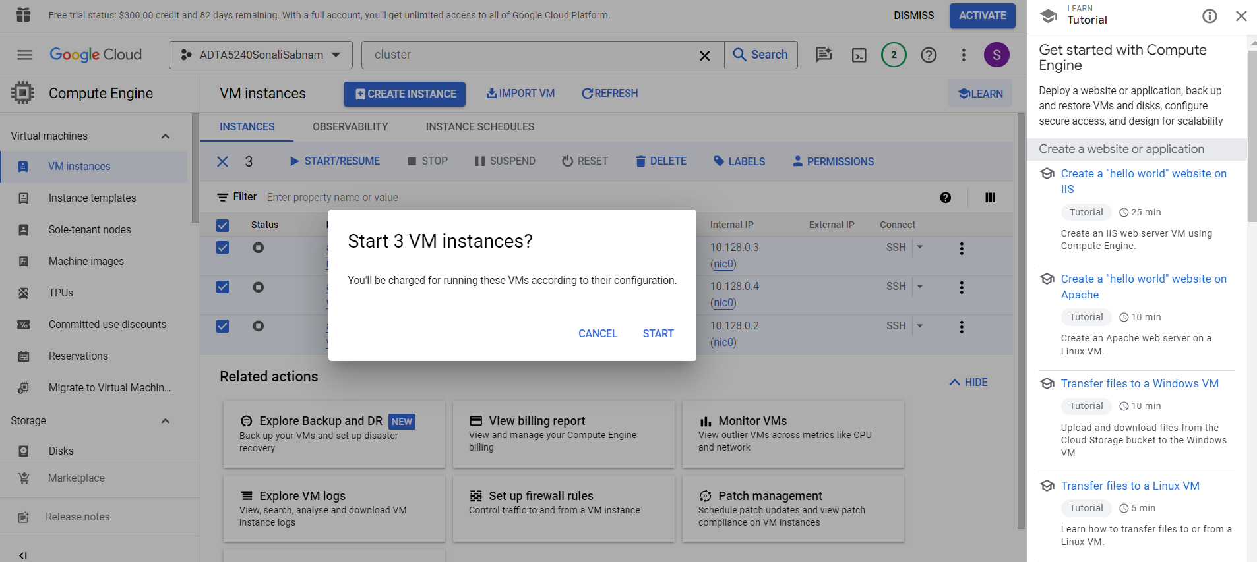

* The cluster is now running.
* We can see the green tick mark and the “START/RESUME” option is disabled in the below screenshot.

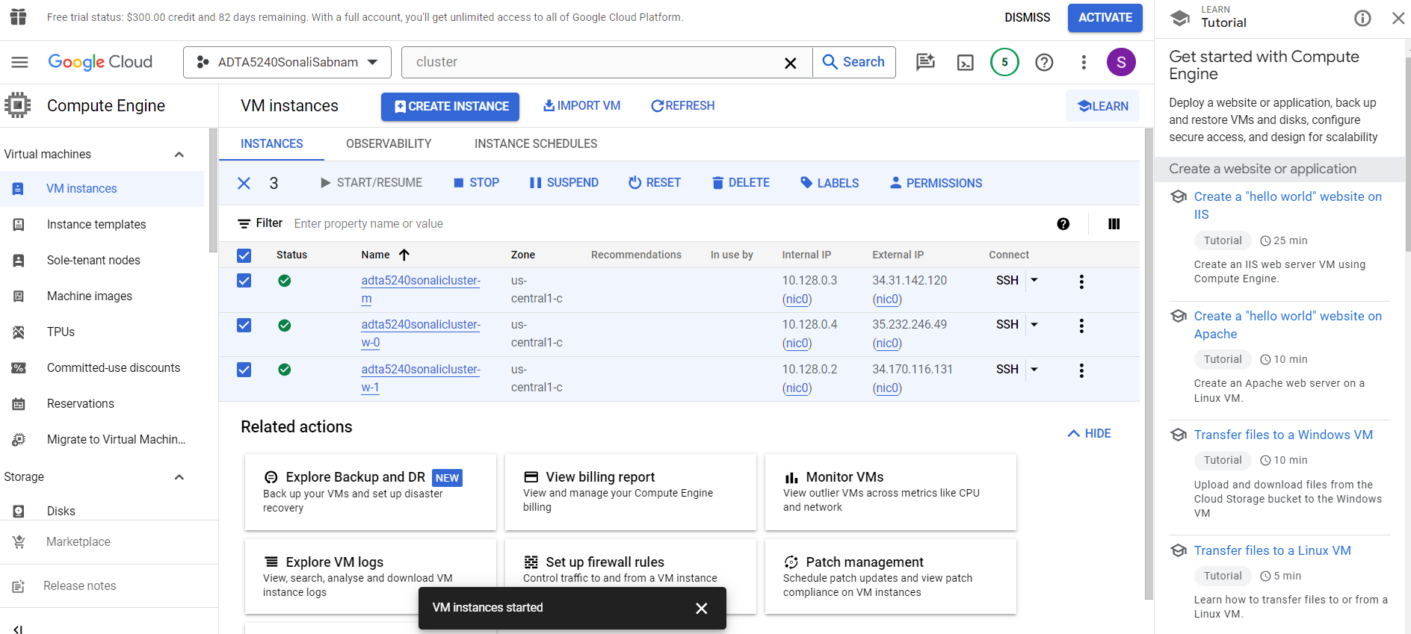

**Step 2: STOP the Cluster**

* If not already in the VM Instances page, Go to “Navigation Menu”, hover on “Compute Engine”🡪VM Instances”.
* Select the checkbox against “Status”, all the below three checkboxes gets checked.
* Now click on “STOP”.
* The below pop-up is displayed.

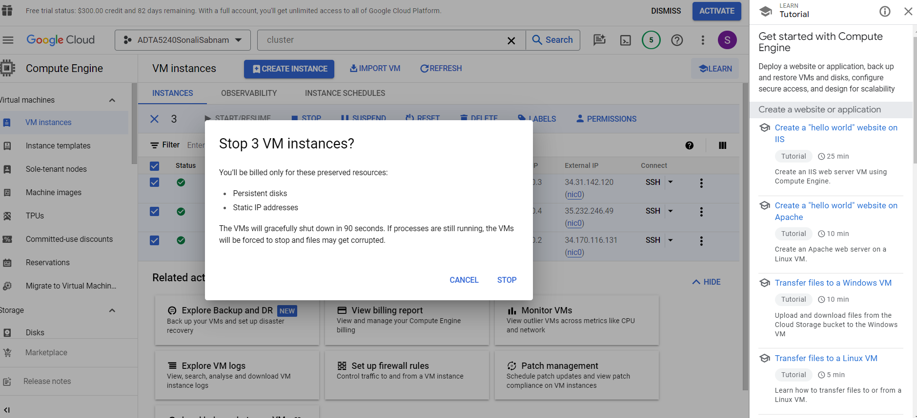

* Click on “STOP”.
* Now the cluster is stopped, and green check mark is gone.
* The “START/RESUME” option is enabled as shown in the below screenshot.

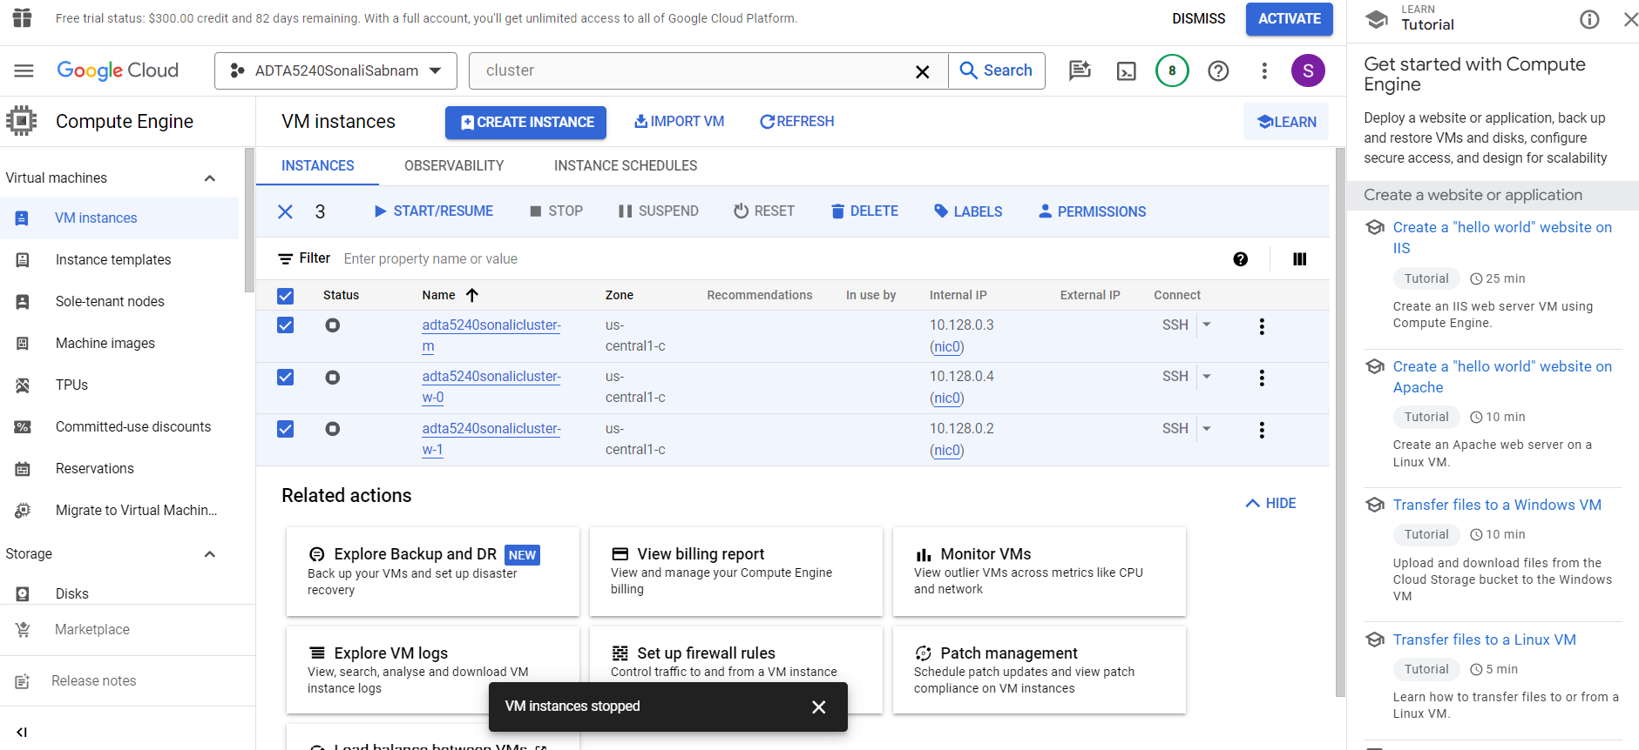

**NOTE: Make sure to Stop the cluster each time to avoid unnecessary charges.**